CSCI 425 Homework #2

1. SELECT Fname, Lname, Address

FROM Employee

WHERE Super_ssn IS NULL;

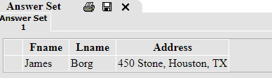

1. SELECT Fname, Lname, Salary

FROM Employee

WHERE Salary >

(SELECT AVG(Salary)

FROM Employee);

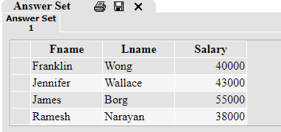

1. SELECT Dname, COUNT(*) AS "Males More Than 30K"

FROM Employee as e, Department as d

WHERE Sex = 'M'

AND Salary > 30000

AND e.Dno = d.Dnumber

GROUP BY Dname;

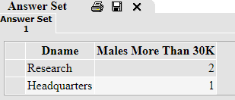

1. SELECT Fname, Minit, Lname

FROM Employee

WHERE Salary >=

((SELECT MIN(Salary)

FROM Employee) + 10000);

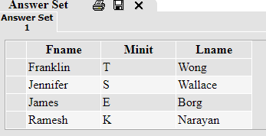

1. SELECT Dname, COUNT(*) as "Employees in Department"

FROM Employee as e, Department as d

WHERE e.Dno = d.Dnumber

GROUP BY Dname;

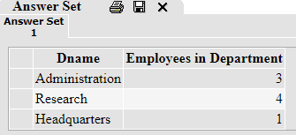

1. SELECT DISTINCT e.Fname, e.Lname, t1.Projects as num_projects

FROM

(SELECT COUNT(*) as "Projects", Dnum

FROM Project as p

GROUP BY Dnum) t1,

Employee as e,

Department as d,

Project as p

WHERE d.Mgr_ssn = e.Ssn

AND p.Dnum = d.Dnumber

AND t1.Dnum = p.Dnum

ORDER BY num_projects;

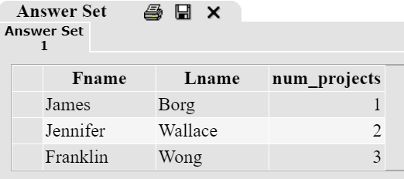

1. SELECT Dname, d.Dnumber, Mgr_ssn, Mgr_start_date,

CASE WHEN Dlocation = 'Sugarland'

THEN Dlocation

ELSE 'N/A'

END

FROM Department as d, Dept_Locations as d_loc

WHERE d_loc.Dnumber = d.Dnumber;

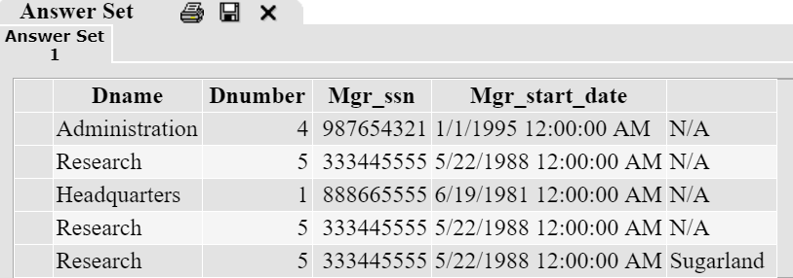

1. SELECT Pname,

CASE WHEN Pname = 'Computerization'

THEN e.Fname

ELSE 'N/A'

END,

CASE WHEN Pname = 'Computerization'

THEN e.Lname

ELSE 'N/A'

END

FROM Project as p, Works_on as w, Employee e

WHERE p.Pnumber = w.Pno

AND e.Ssn = w.Essn;

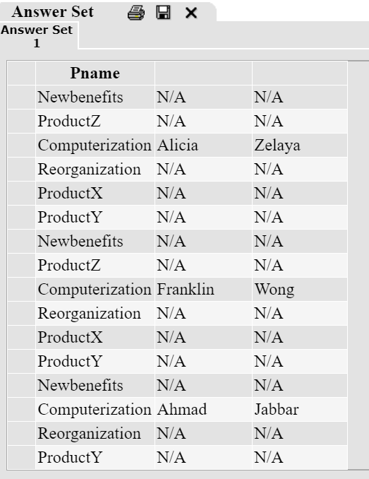

1. CREATE VIEW department_info

AS SELECT Dname, Fname, Lname, Salary

FROM Department AS d, Employee AS e

WHERE d.Mgr_ssn = e.Ssn;

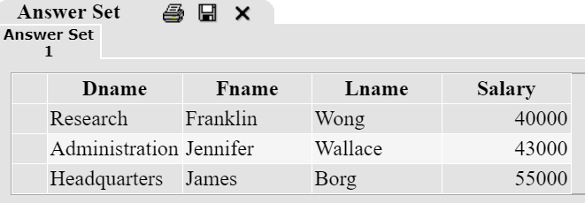

1. CREATE VIEW research_info

AS SELECT e.Fname AS emp_first_name, e.Lname AS emp_last_name, e.Salary, manager.Fname manager_first_name, manager.Lname manager_last_name

FROM Employee AS e

FULL OUTER JOIN Department ON Department.Dnumber = e.Dno

LEFT JOIN Employee as manager on e.Super_ssn = manager.Ssn

WHERE Dname = 'Research';

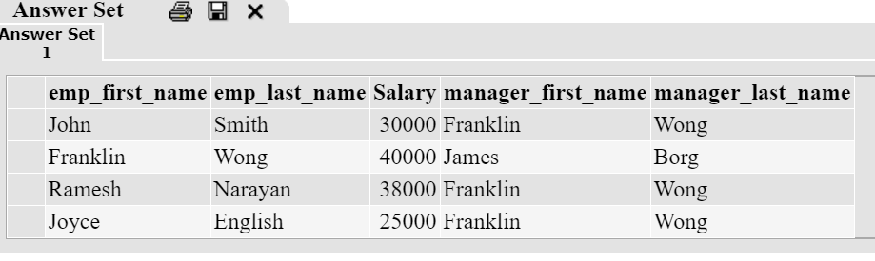

1. CREATE VIEW Project_Info

AS SELECT DISTINCT Dname, p.Pname, pInfo.num_employees, pInfo.hours

FROM Project AS p

JOIN Department as d ON p.Dnum = d.Dnumber

FULL OUTER JOIN Works_on as w ON w.Pno = p.Pnumber

JOIN

(SELECT Pname, COUNT(*) as num_employees, SUM(Hours) as hours

FROM Project AS p

JOIN Department as d ON p.Dnum = d.Dnumber

FULL OUTER JOIN Works_on as w ON w.Pno = p.Pnumber

GROUP BY Pname)

AS pInfo

ON p.Pname = pInfo.Pname;

